Question Bank for IA

- What is Regression Analysis?
- State the Properties of Arithmetic mean?
- Define Binomial distribution?
- Define Statistics?
- What are different types of correlation?

- Calculate Spearmans Rank Correlation?
Ad Cost ('000 Rs.) | 39 | 65 | 62 | 90 | 82 | 75 | 25 | 98 | 36 | 78
Sales (Lakhs Rs.) | 47 | 53 | 58 | 86 | 62 | 68 | 60 | 91 | 51 | 84

- Find the Geometric Mean of the following data:
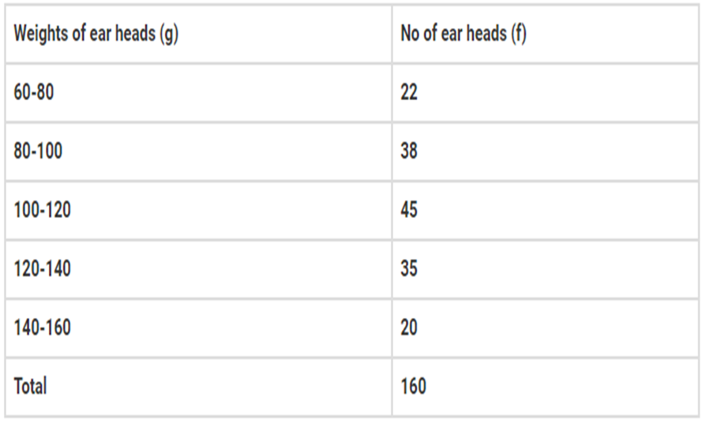

- The management of a photograph record company has observed that the number of defects on records follows a Poisson distribution with a mean of 0.4
- What is the probability that a record selected at random will have 3 defects?
- If the management enforces a policy stating that records sold to customers must have no defects, what percentage of the total record production will be unsuitable for sales due to defects?

- The table below shows the distribution of refrigerators turned in for new models based on their life spans (in years). Two models, A and B, are compared for the variation in their weights with respect to heights.

Life Span (No. of Years) | Number of Refrigerators (Model A) | Number of Refrigerators (Model B)
0 - 5 | 8 | 6
5 - 10 | 12 | 10
10 - 15 | 17 | 20
15 - 20 | 10 | 12
20 - 25 | 3 | 2

What is the average life of each model of these refrigerators?
Which model shows more uniformity in terms of life span?

- In two factories A and B engaged in the same industry, the average monthly wages and variances are as follows:
Factory | Average monthly wages | Variance of the distribution | No. of wage earners
A | 5000 | 900 | 550
B | 4500 | 1600 | 650
Which factory A and B pays higher amount as monthly wages
Which factory shows greater variability in the distribution of wages

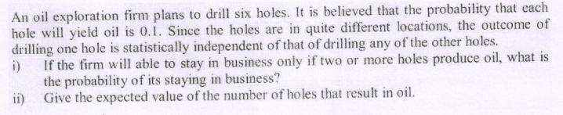

- Using the data provided below, solve the following:
- Calculate the two regression coefficients.
- Derive the two regression equations.
- Determine the most likely marks in Statistics when marks in Economics are 30.

Marks in Economics | 25 | 28 | 35 | 32 | 31 | 36 | 29 | 38 | 34 | 32
Marks in Statistics | 43 | 46 | 49 | 41 | 36 | 32 | 31 | 30 | 33 | 39

Q8)
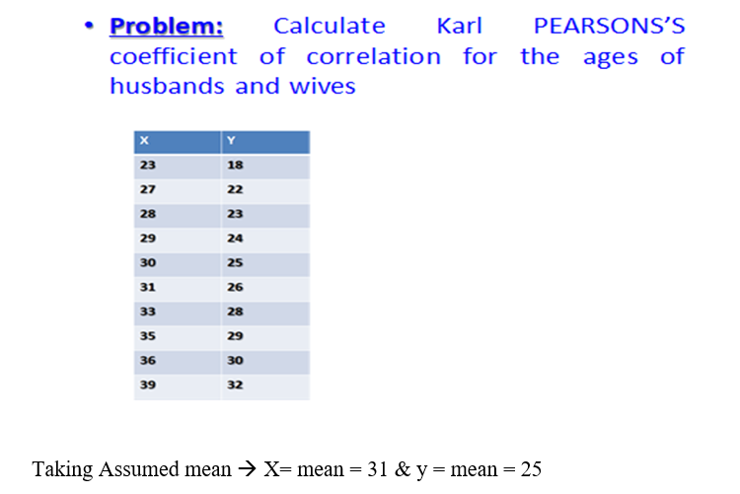
Q 9) The following distribution gives the pattern of overtime work per week done by 100 employees of a company. Calculate first quartile, and seventh decile & 60 Percentile.

